**Disease Master**

* PURPOSE OF THE Disease Master.

“Disease Master” is used in “Patient Master”.

1. Select “Disease Master” Menu Path :-Masters-> Pharma Retails Masters--> Disease Master.

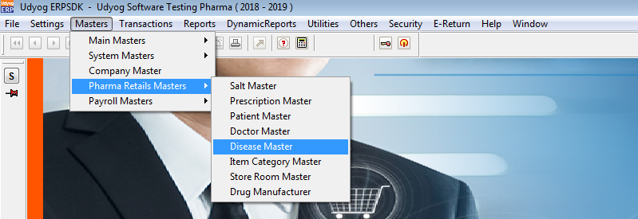

2.After Click On “Disease Master”

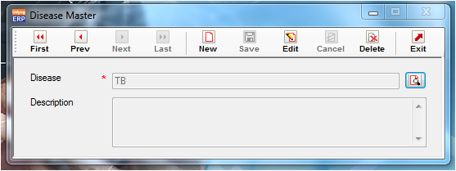

3.Below mentioned disease name are available in default.

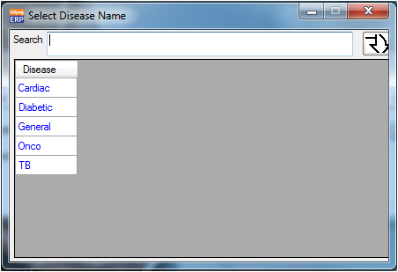

4. Validation list.

1. Duplicate Record not allowed.